**Week - 12**

**Week – 12 User defined functions**

**Reg no : 241001159**

**Name : PADHMAVATHY.M**

**Q1)**

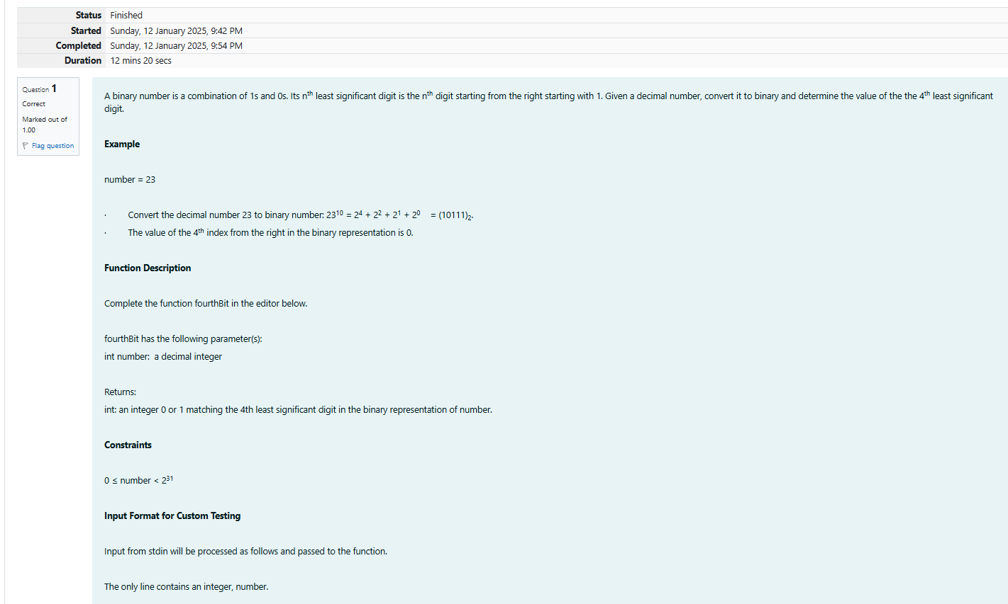

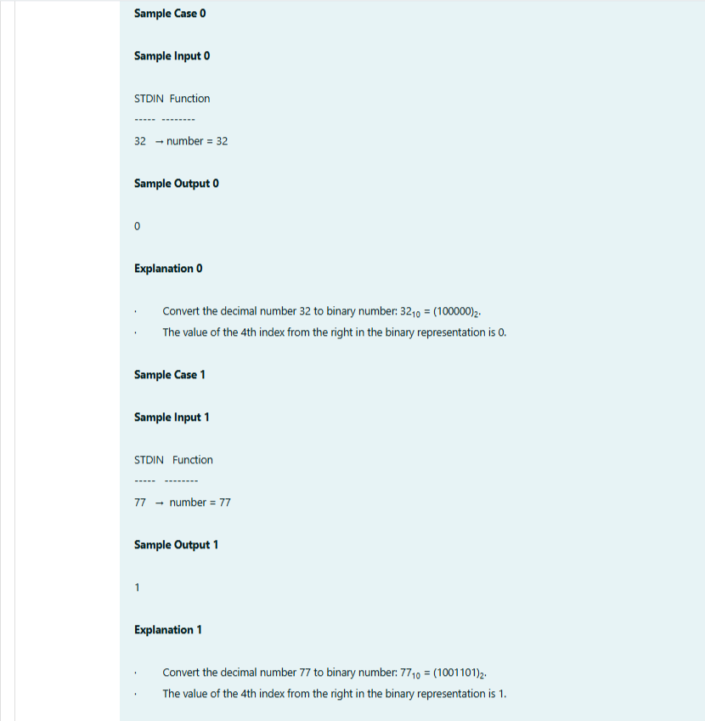

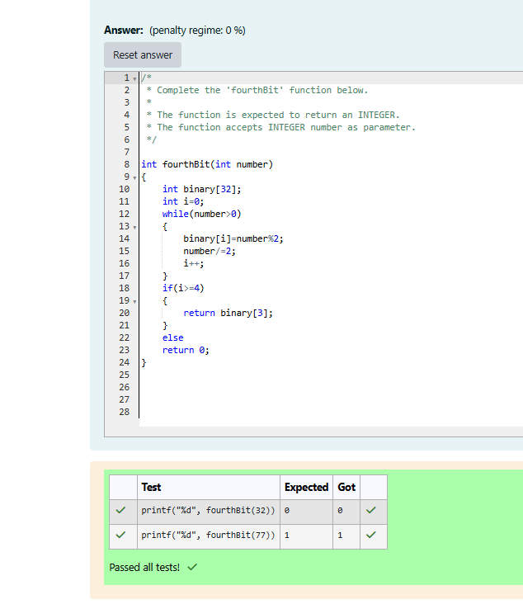

**Week – 12 User defined functions**

**Reg no : 241001159**

**Name : PADMAVATHY.M**

**Q2)** 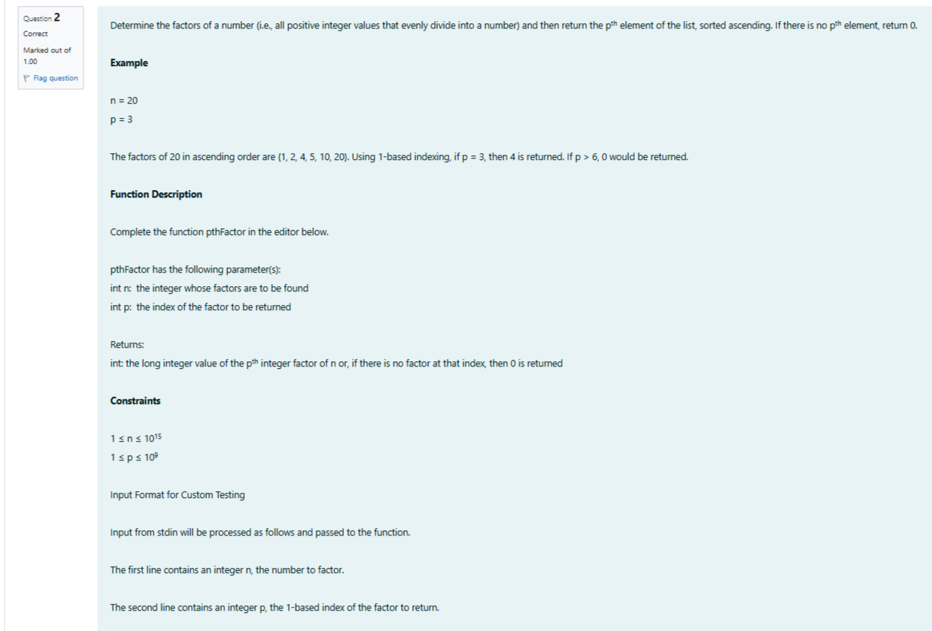

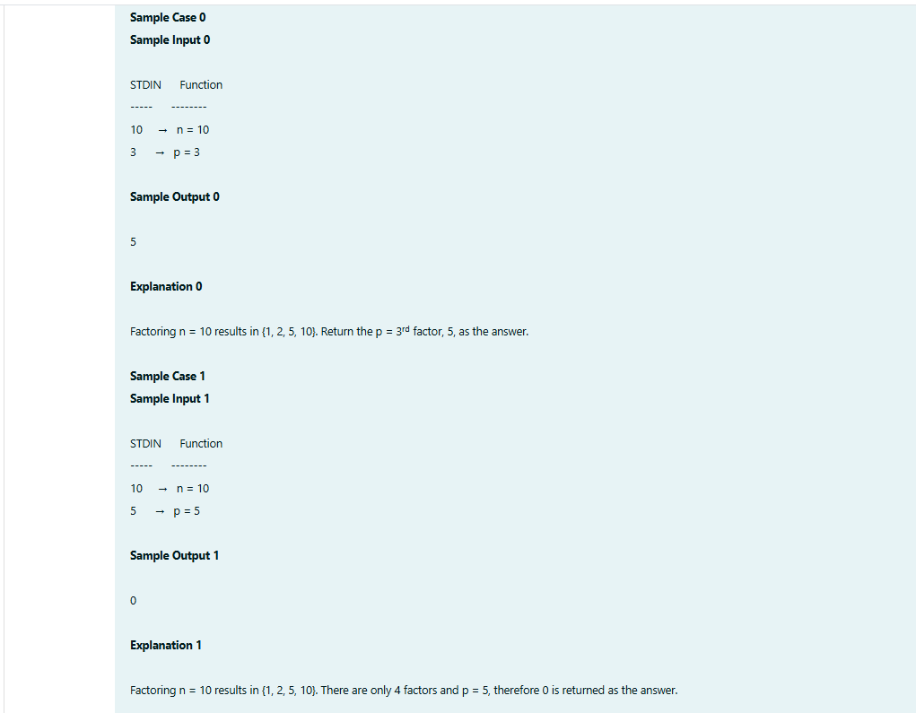

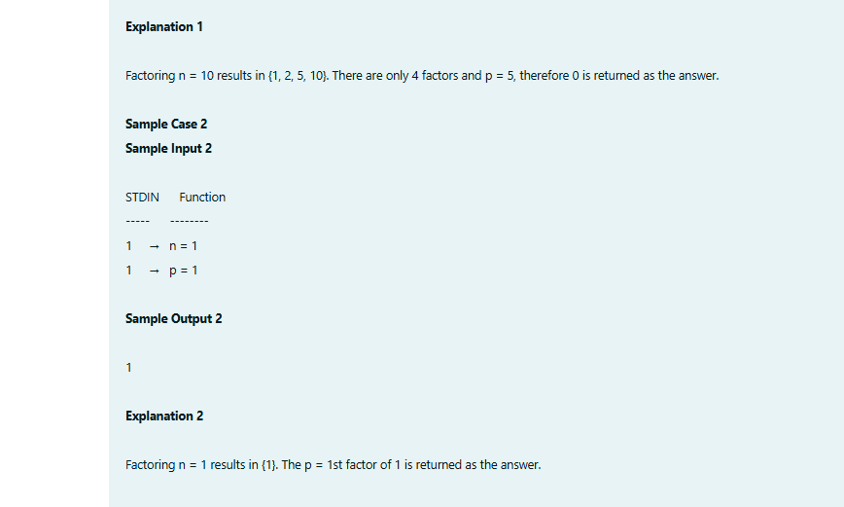

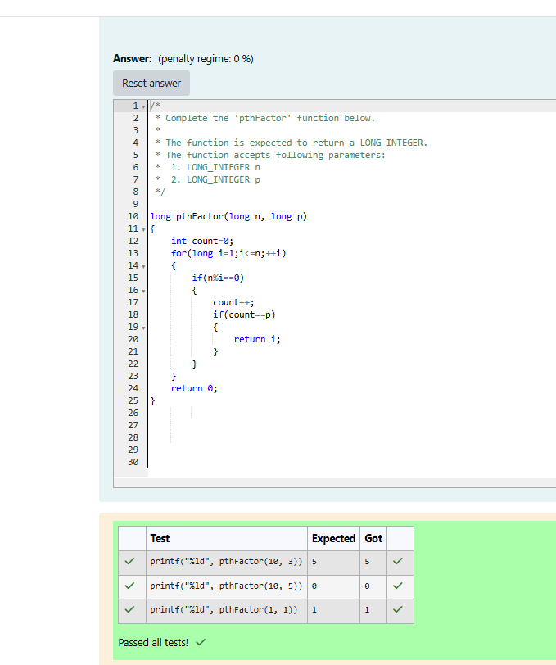

**Week – 12 recursive functions**

**Reg no : 241001159**

**Name : Padhmavathy.M**

**Q1)**

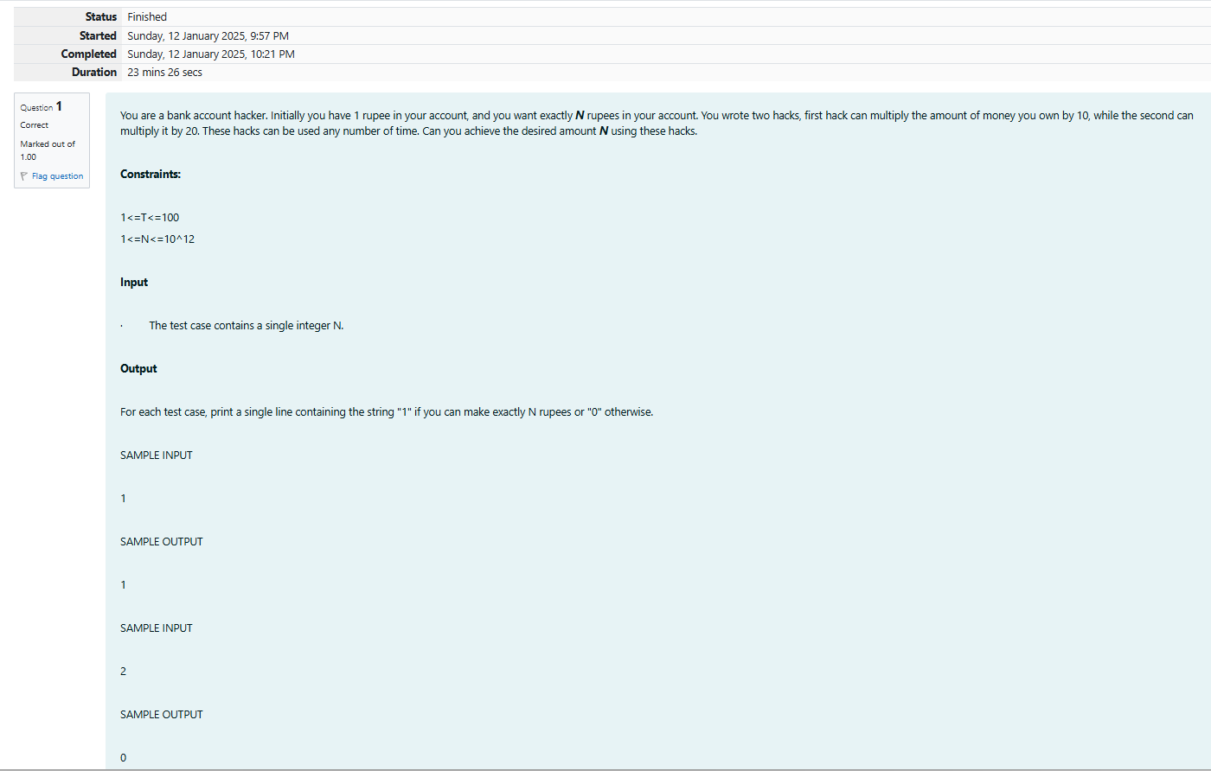

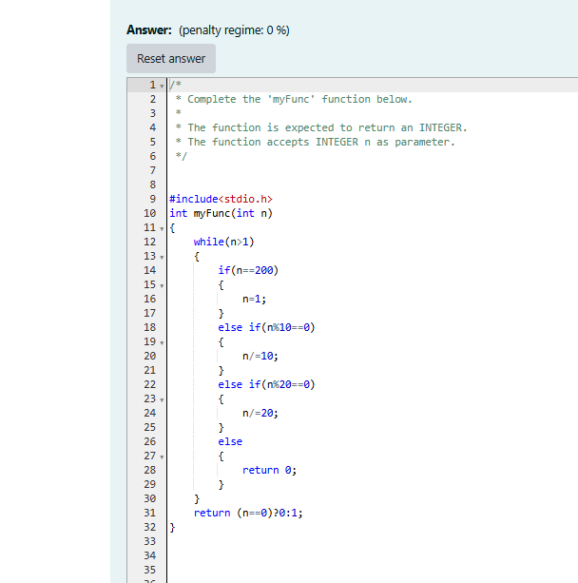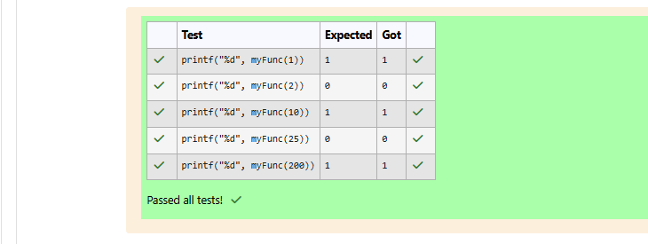

**Week – 12 recursive functions**

**Reg no : 241001159**

**Name : PADMAVATHY.M**

**Q2)**

